**LAB 11**

[](https://youtu.be/0xcYt5isH8I)

**https://youtu.be/0xcYt5isH8I**

1. Create a new project:

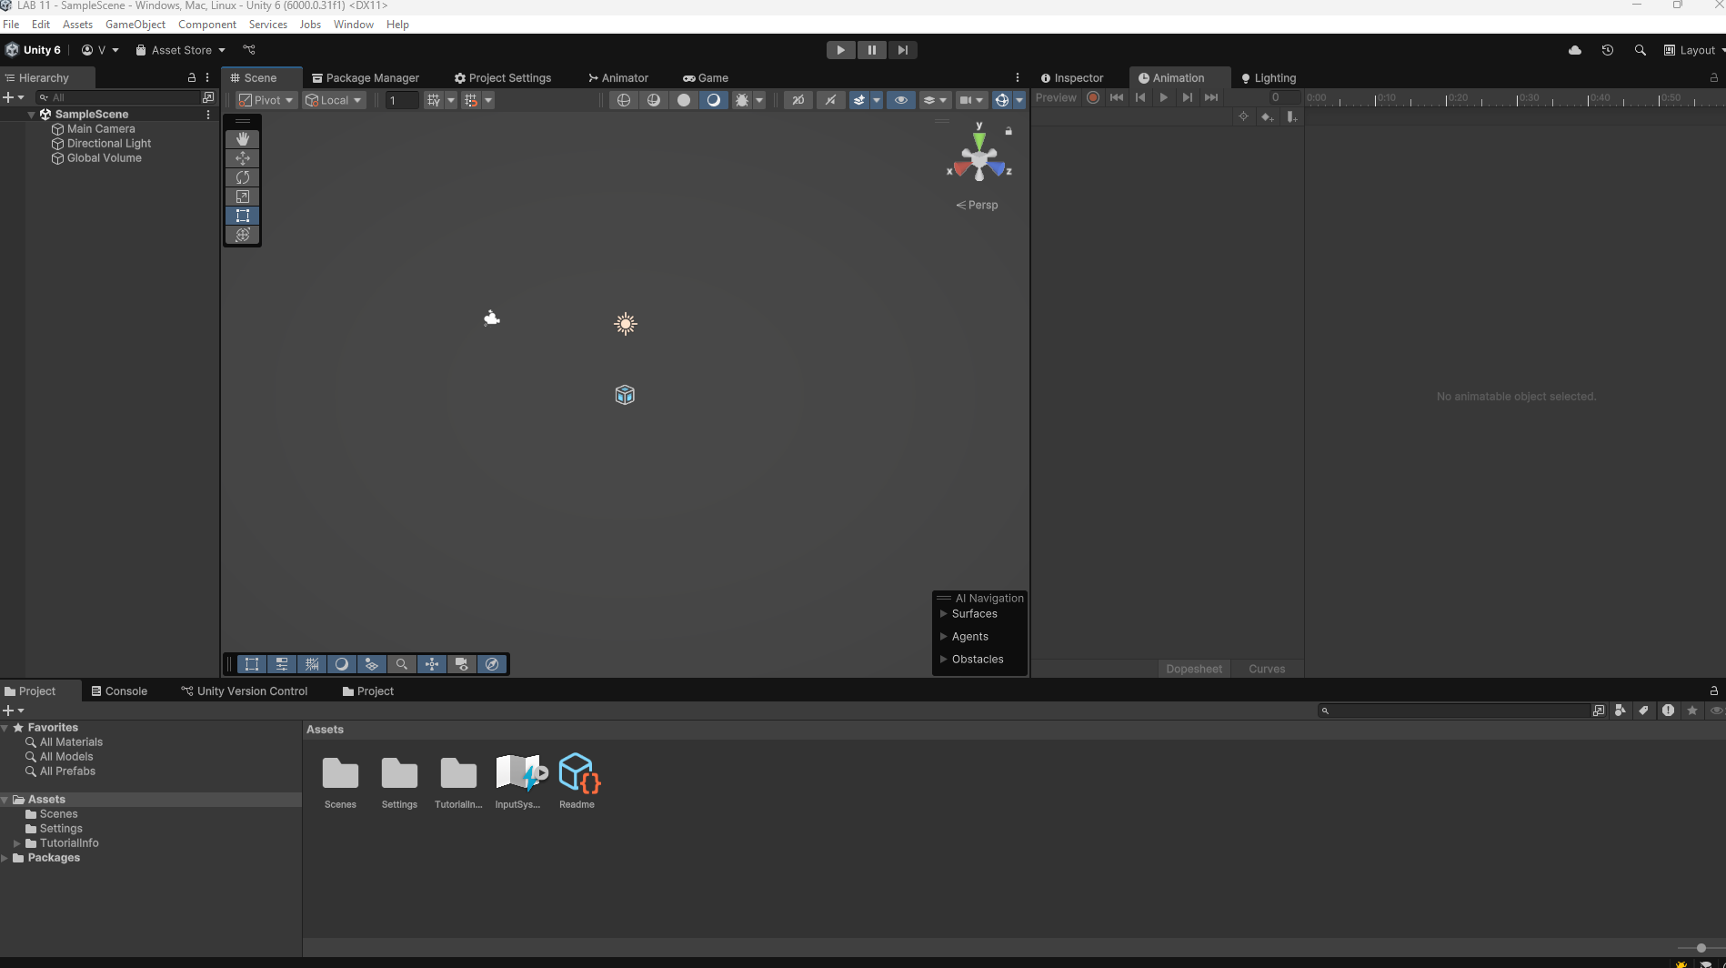

1. Add Canavas Button Text and Scroll Area

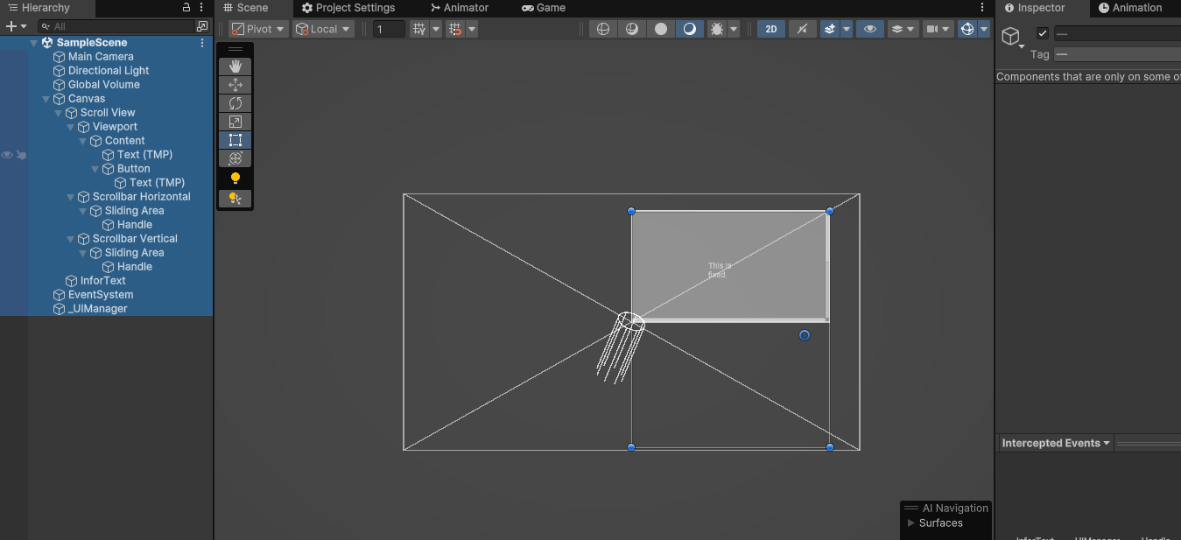

1. Create a UI Manager Script assign it to a empty UI Manager game object and assign you button scroll area and text to it.

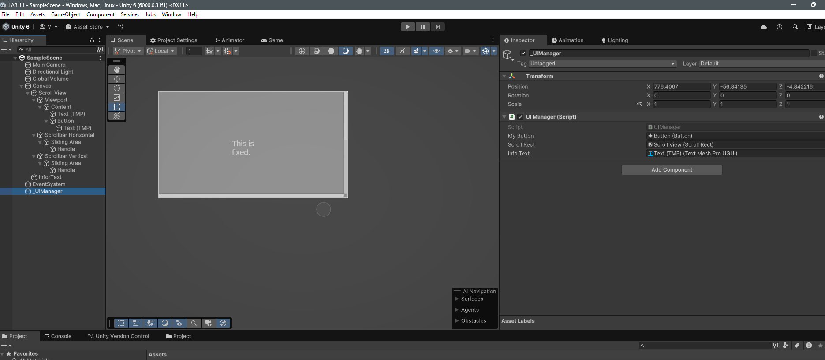

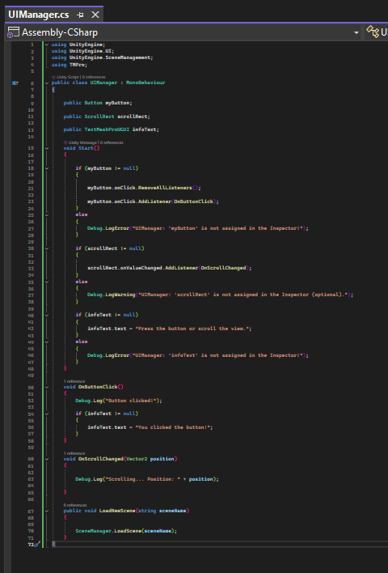

1. Play test the game.